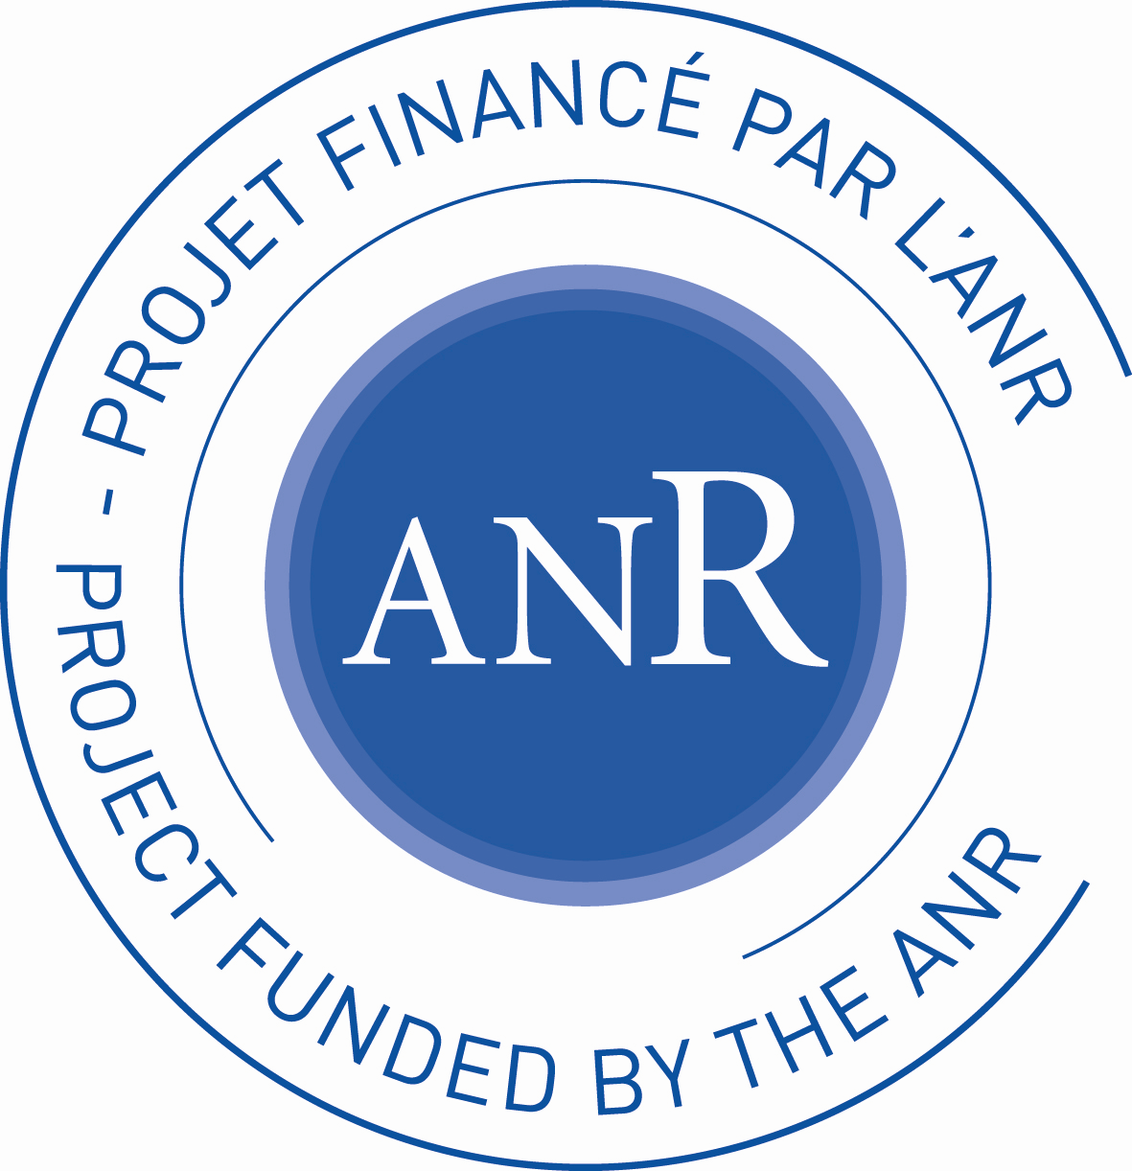

Open PhD position

Development of electrically pumped hybrid perovskite- based light-emitting devices

Employer: University of Limoges, CNRS
Workplace: XLIM Research Institute, Limoges, France
Expected starting date: 01/2019
Salary: ~1500€ net per month

Title of the position

PHD position on Science and Systems Engineering, Mathematics, Informatics.
“Development of electrically pumped hybrid perovskite- based light-emitting devices”

General information

The work will take place at XLIM Research Institute, in Limoges (France, www.xlim.fr) under Prof. Bernard Ratier and Dr. Rémi Antony scientific supervision. The contract will be for a period of 3 years and the expected starting date is 01/2019. This will be a full-time post with a salary around 1500€ net per month.

Description of the thesis subject

This position is proposed in the framework of the EMIPERO project, which was selected in 2018 by the French Research National Agency (ANR), and which associates three well-recognized academic partners: Laboratoire Aimé Cotton LAC, ENS Cachan ; the Institute for Nanotechnologies INL, Lyon ; XLIM Institute, Limoges.

Hybrid organic perovskite (HOP) materials have emerged as a relevant alternative to thin film solar cell technologies in the last few years, with power conversion efficiencies rapidly passing the 20% threshold . Following these rapid developments, perovskite light-emitting devices, such as light-emitting diodes (PeLED) and laser diodes (LD), have also shown strong potentialities .
In this context, the aim of the consortium is to realize electrically pumped hybrid perovskites based light-emitting devices, by proposing an integrated study from the fundamental properties of the material in a view of its optimization toward the laser effect, to the characterization of device performance in an optical link in the frame of visible light communications (VLC). The achievement of the devices relies on the skills of three complementary teams: a specialist of hybrid perovskites, a specialist of nanophotonics for light emission, and a third multidisciplinary entity, specialist of organic semiconductors and more recently hybrid perovskites based optoelectronic devices, of VLC and of light propagation modeling.

The successful applicant will be in charge of the development of various PeLED device architectures based on emitting HOPs developed by our partners. A special focus will be paid on the optimization and the characterization of the PeLED devices under high injection regime and effort will be dedicated to charge injection modelling in order to obtain electrically pumped perovskite μ-lasers. A second aspect of the position will be focusing on the VLC applications, involving assessment of the modulation speeds and control of emission pattern using flexible PeLEDs.

Work context

The National Center for Scientific Research, or CNRS, is a public organization under the responsibility of the French Ministry of Education, Research and Innovation. Founded in 1939, it covers all scientific disciplines, including the humanities and social sciences, biological sciences, nuclear and particle physics, information sciences, engineering and systems, physics, mathematical sciences, chemistry, Earth sciences and astronomy, ecology and the environment. Eighteen regional CNRS delegations are the main interlocutors of the organization's partners in the field. They have a role of management and local support of laboratories spread over the territory. In particular, they help to set up industrial projects and European programs. In this context, the Center Limousin Poitou-Charentes Regional Delegation covers 2 administrative regions with 67 laboratories or units located in 7 departments and associated with 5 universities.

The doctoral school n°610, Science and Systems Engineering, Mathematics, Informatics (SISMI) is directed by Prof. Bernard Jarry. It covers the following disciplines: Mathematics, Microwaves, Photonics, Informatics, Images, Automatics and their Interactions. It delivers the following thesis references: Mathematics and applications, Informatics and applications, High frequency electronics, photonics and systems, Image, signal and automatic. It is attached to 4 institutions (COMUE Leonard de Vinci, Limoges University, Poitiers University and ASE/ENSMA in Poitiers). It relies on 3 partner laboratories : XLIM, LMA and LIAS. 250 doctoral students are enrolled in the doctoral school SISMI.

XLIM is a joined Research laboratory (UMR 7252) between the French National Research Center (CNRS) and the University of Limoges. It has a strong expertise in electronics and microwaves, optics and photonics, CAD, mathematics, computer sciences and image processing for the application in secured environments, biotechnology and health, energy control and saving. XLIM is a multidisciplinary research institute located on several geographical sites, and it incorporates more than 440 people among professors, CNRS researchers, engineers, technicians, post-doctoral researchers, PhD students and administrative staff (website: www.xlim.fr)

The “Printed Electronics for Telecoms and Energy” (ELITE) team at XLIM has been focusing for the last two decades on the electrical and optoelectronic characterization of organic and hybrid semiconductors and devices, with a special focus on third generation solar cells, light-emitting diodes, thin film transistors (see the group webpage). Major developments have been demonstrated in the group in the field of organic and hybrid devices, including hybrid perovskite materials and ink-jet printing technologies. More generally, the group is focusing on interfaces, which are crucial components for any functional device. The group is managing its own technology platform devoted to Printed Electronics, which is part of the PLATINOM facility, the technological resource center of XLIM, open to academic and industrial partners for developments in the field of RF components and circuits, and Photonics.

Profile of the candidates
Applicants must hold a Master's degree (or be about to earn one) or have a university degree equivalent to a European Master's (5-year duration). He/she will demonstrate a relevant training in semiconductor Physics and Nanotechnologies, and will show a suitable interest for experimental work. Knowledge or past experiences in the field of organic optoelectronics (solar cells, OLED, etc) or halide perovskites will be an advantage, as well as a high level of communication skills, both oral and written (French and English required) to be able to present at conferences and write articles in scientific publications. In addition, the candidate must be able to work in a team on multi-disciplinary projects.
Applicants must send by email their cover letter, a detailed CV including detailed transcripts of last and current Diploma, as well as two reference letters, to:

Dr. Rémi ANTONY and Prof. Bernard RATIER
remi.antony@unilim.fr / bernard.ratier@unilim.fr
XLIM UMR 7252, RF-ELITE
Université de Limoges/CNRS
Tel: +33 (0)5 87 50 67 63 / +33 (0)5 87 50 67 64

- Seok S.I., Grätzel M. and Park N.G., “Methodologies toward highly efficient perovskite solar cells”, Small, 2018, 14 (2018) 1704177;
- Shan Q., Song J., Zou Y. and Zeng H., “High performance metal halide perovskitel light-emitting diode: from material design to device optimization”, Small, 2017, 13, 1701770.

